**Tiny ML**

**Index**

1. Introduction
2. Machine Learning Pipeline
3. TinyML Example
4. Challenges

**Introduction**

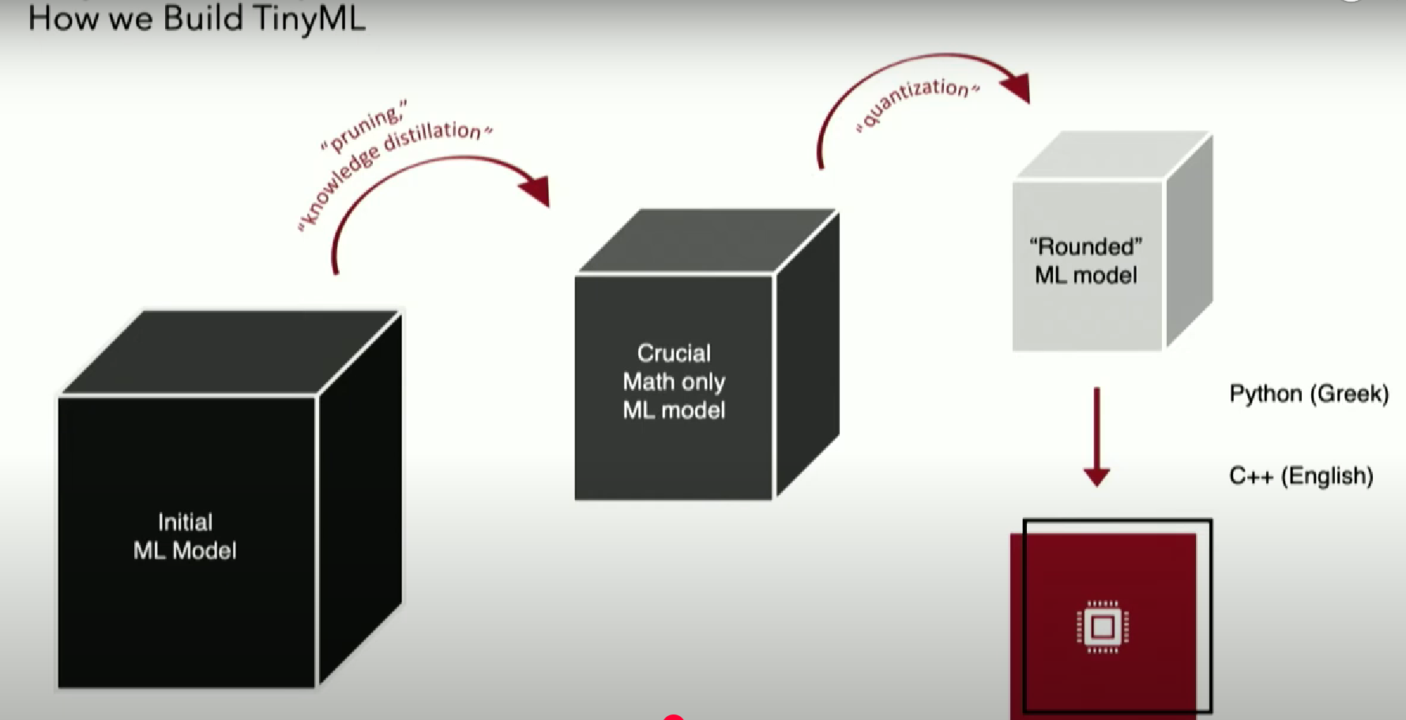

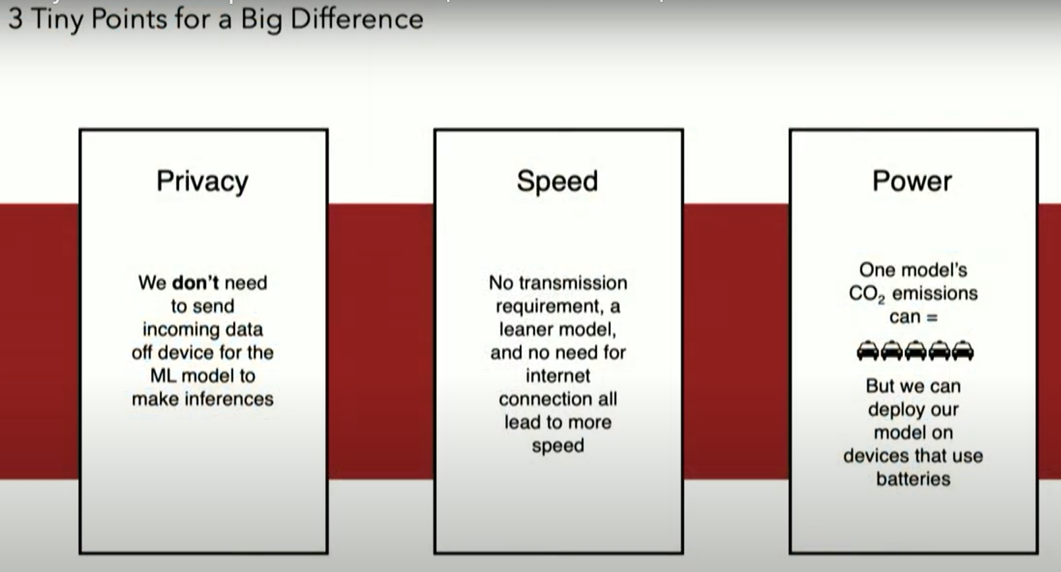

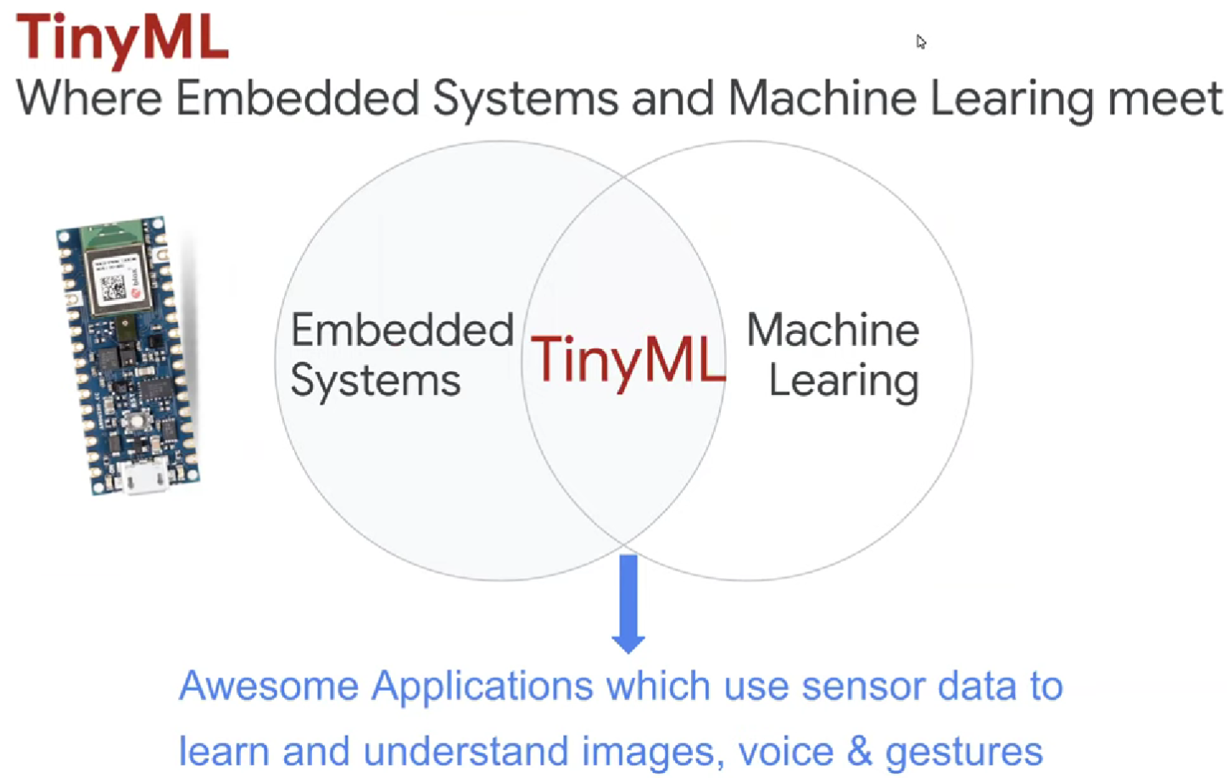

**Machine Learning Pipeline**

Step 1:

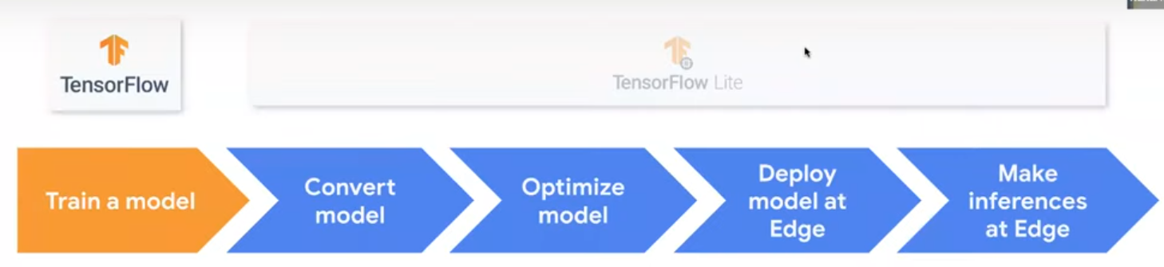  
1. Capturing sensor data

2. Building your dataset

3. Constructing Neural Networks Models

4. Train them

Step 2:

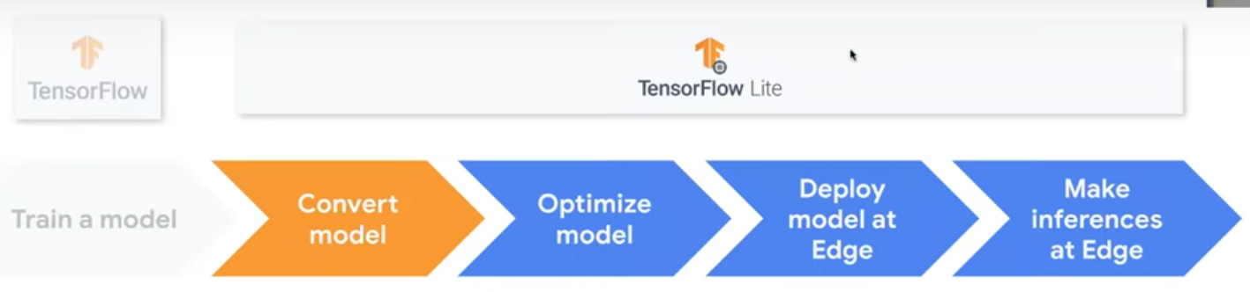  
1. Make these models to work on embedded hardware by converting them.

Step 3:  
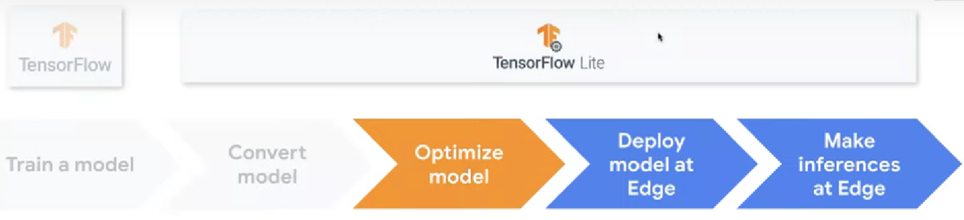

Optimize them for size, speed and energy, so that they can run on microcontrollers and interact with us in real time.

Step 4:  
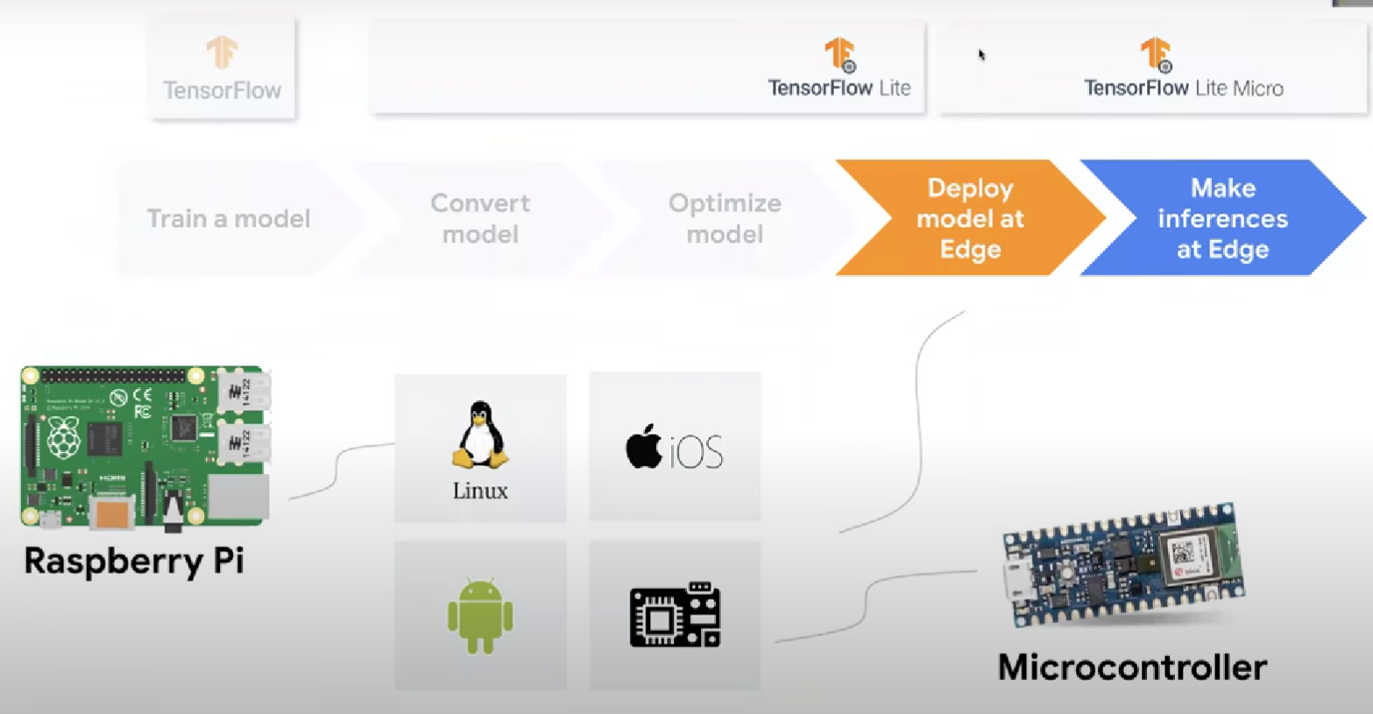

**TinyML Example**



3 Fundamental steps here are:

Step 1 = Input( mainly from sensors)  
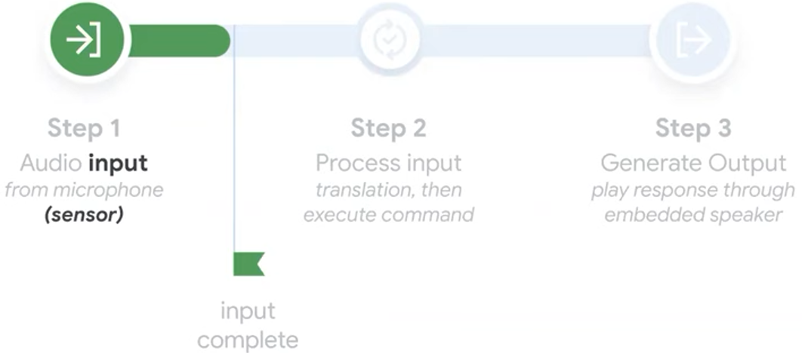

Step 2 = Processing( data can be from multiple sensors or inputs)  
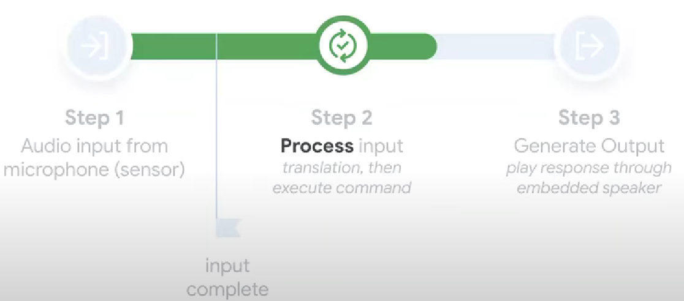

In Processor in terms of Size -

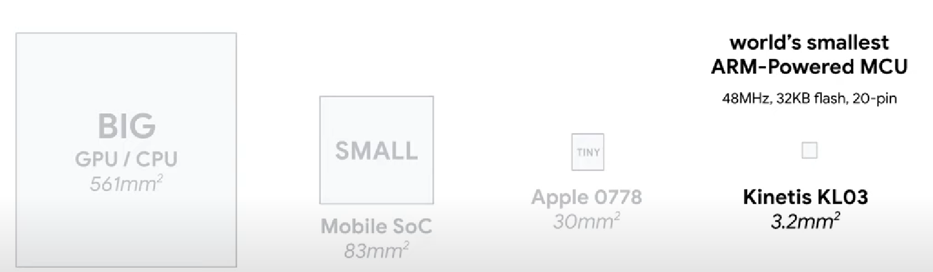

In terms of power consumption -

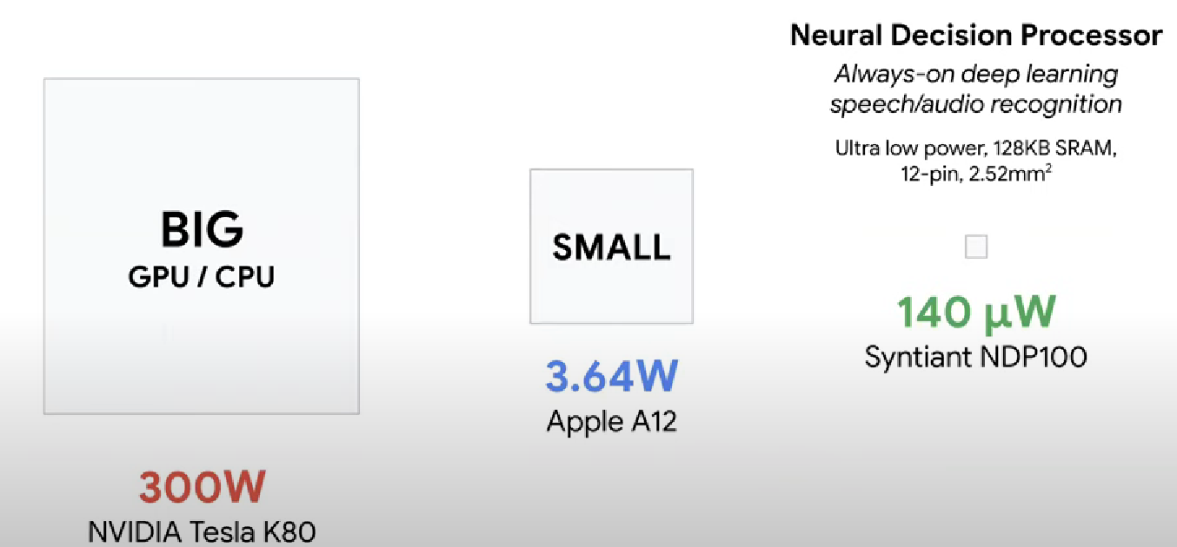

Step 3 = Output (mainly some hardware actuation like trigger speakers, digital actuation like send some signal to the screen)  
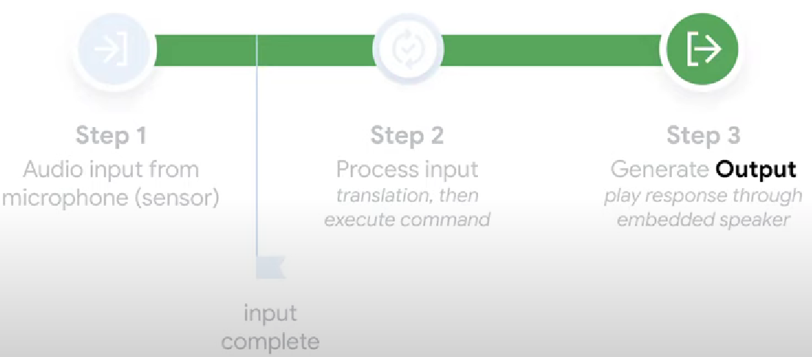

MCUs enable TinyML = Microcontrollers are really small in size, consume very low power and costs very less.

**Challenges**

1. Hardware

Typically, when you consider any computing device it is made of 3 fundamental components – Compute, Memory and Storage  
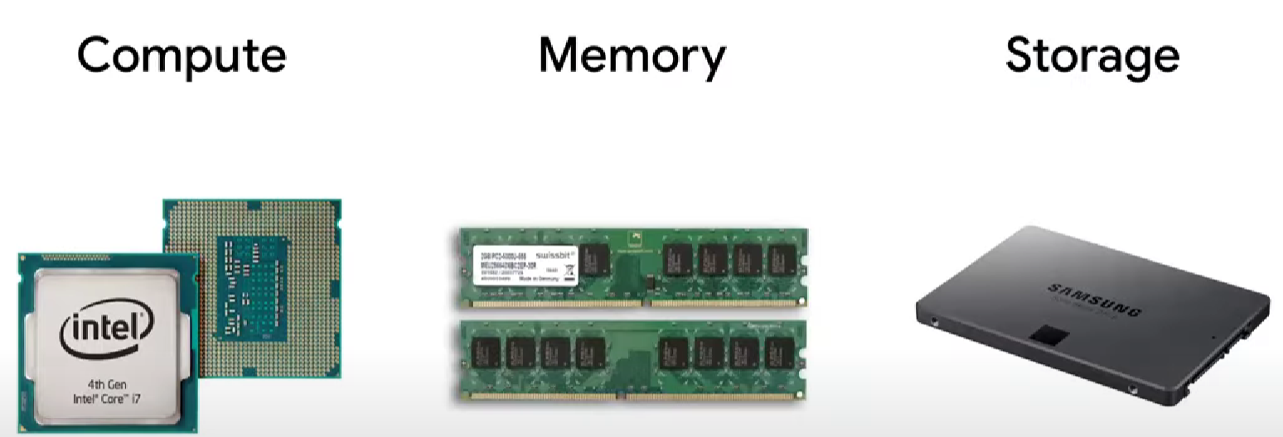

Compute is a Brain, where the processing takes place. Memory is to store the data like short term memory. Storage is like permanent harddisk (if It is powered off the data still remains which is called as non-volatile memory).

* Difference between microprocessor and microcontroller

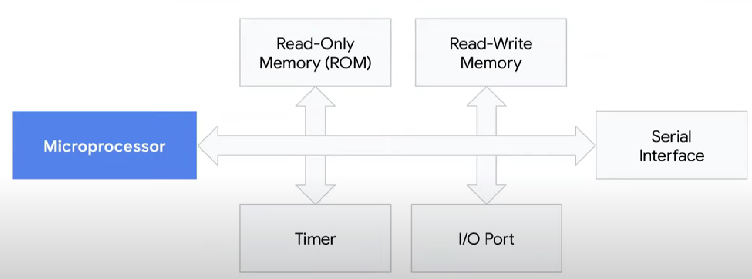

Microcontroller  
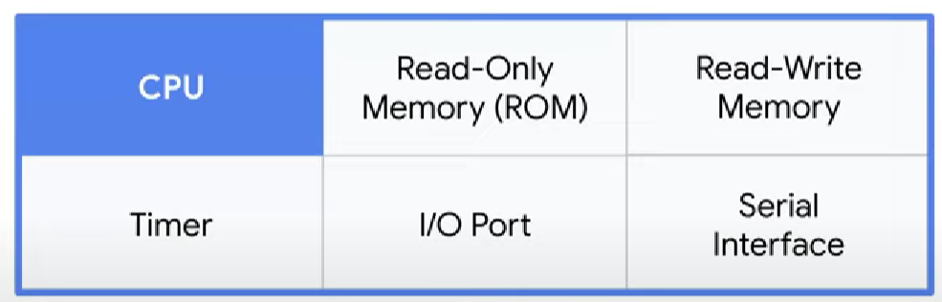  
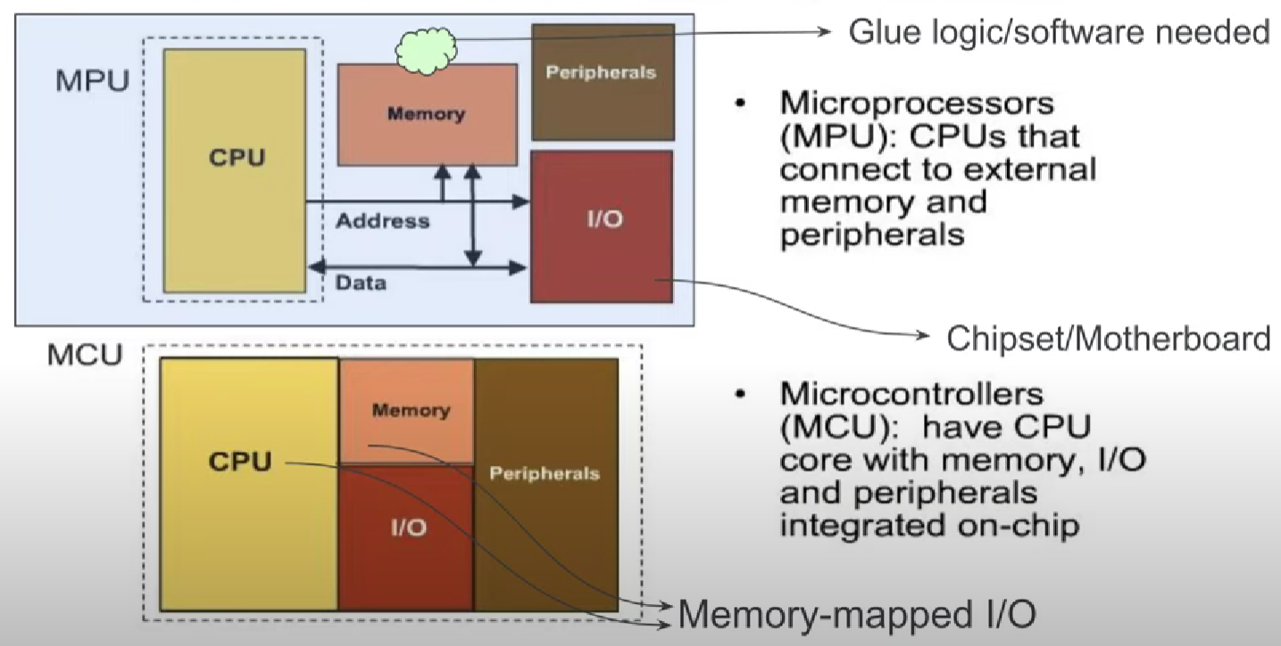

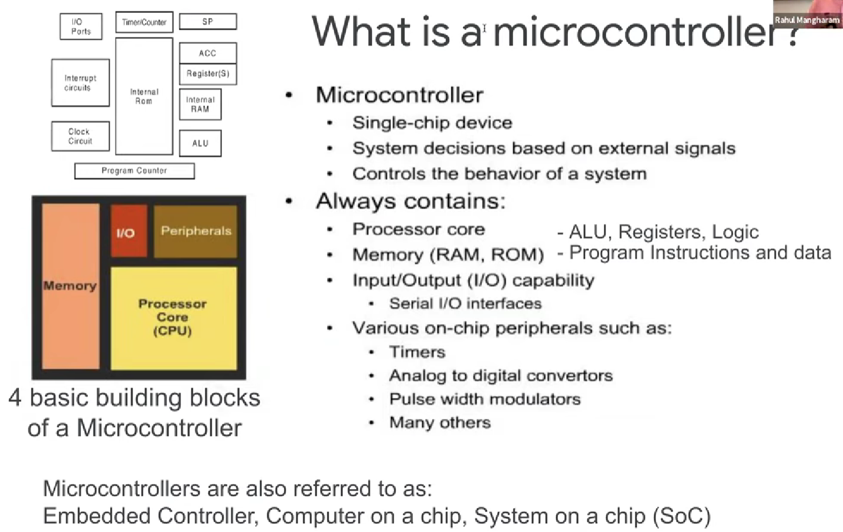

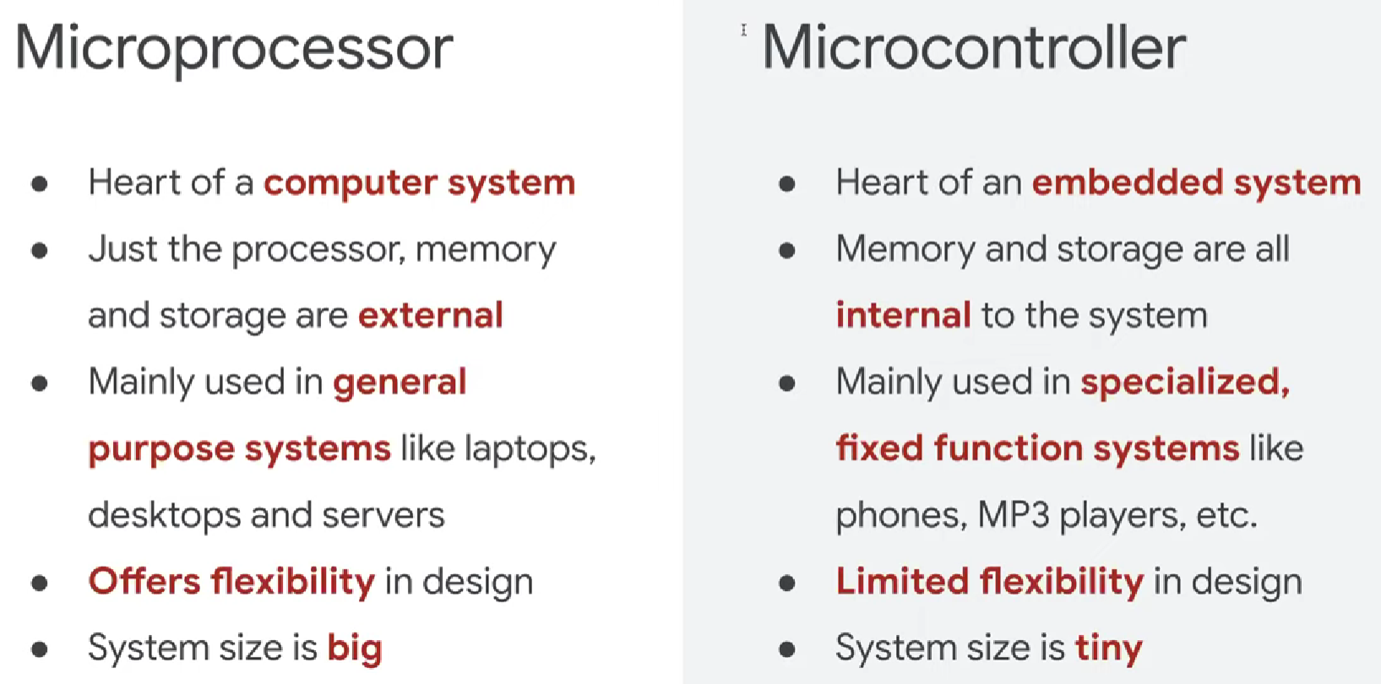

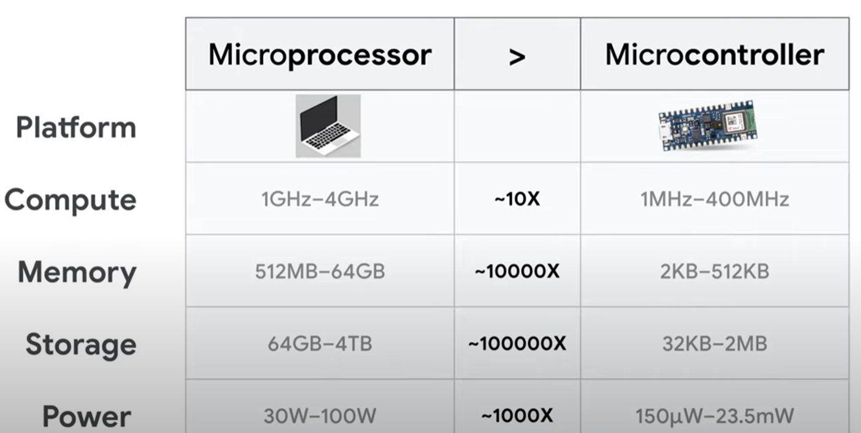

1. Software  
   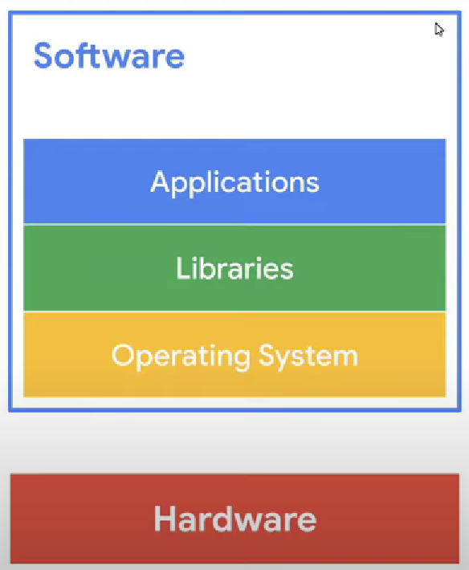  
   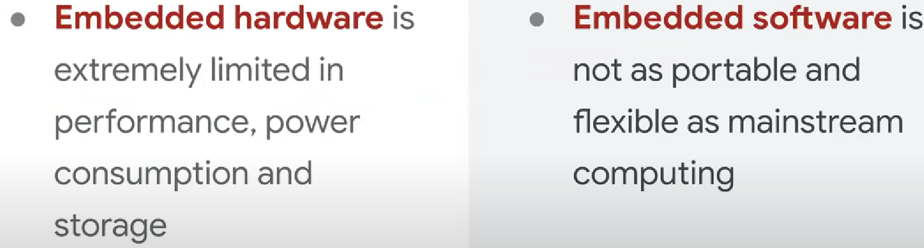
2. Machine Learning

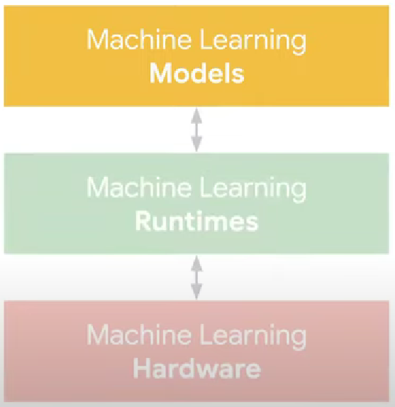 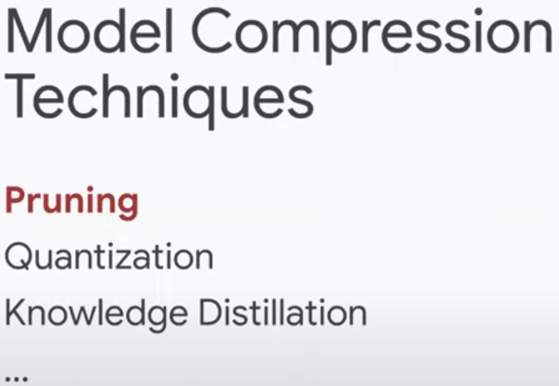

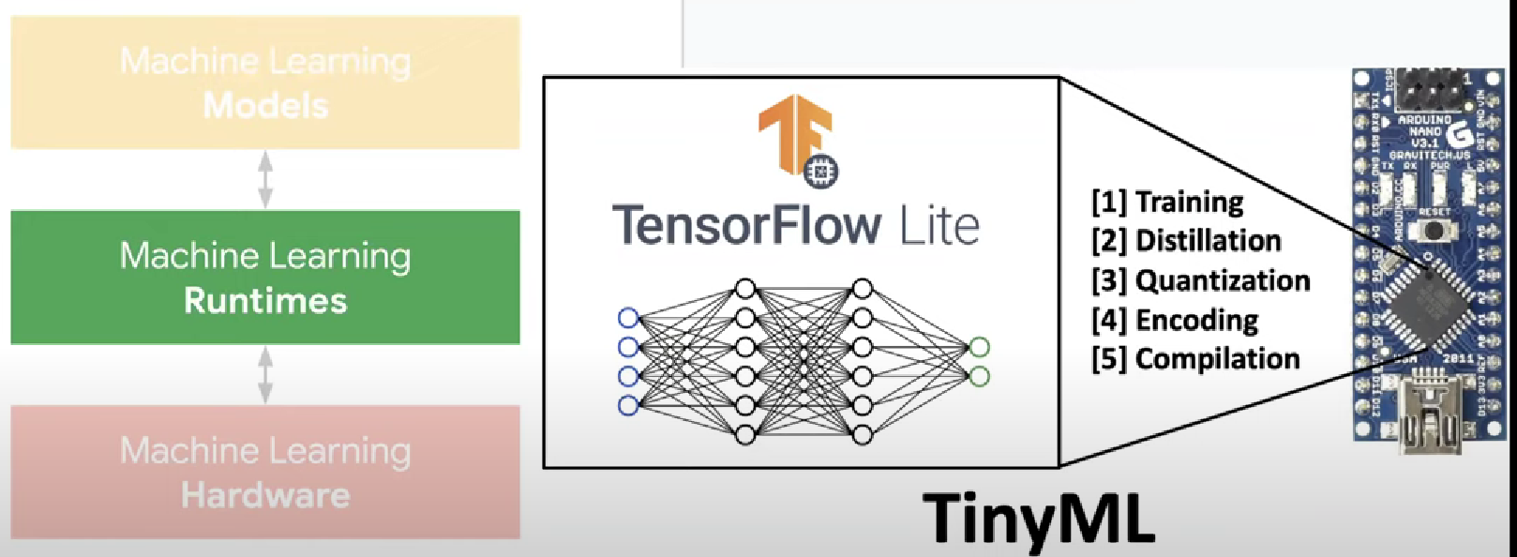

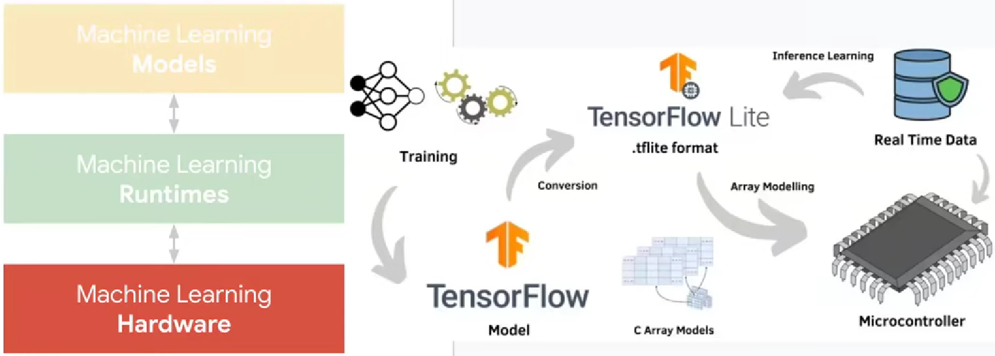

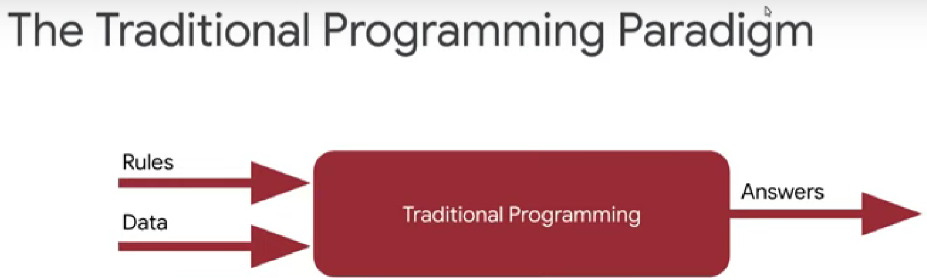

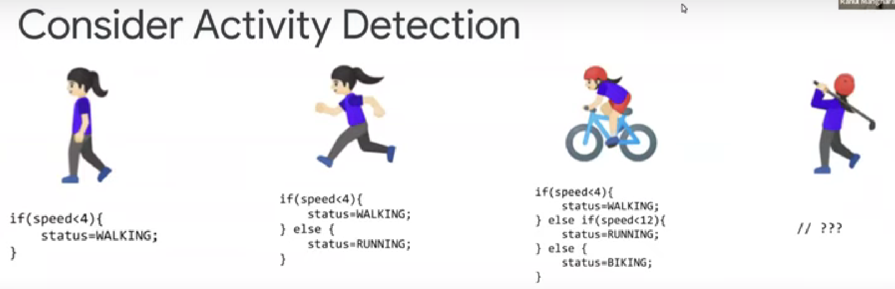

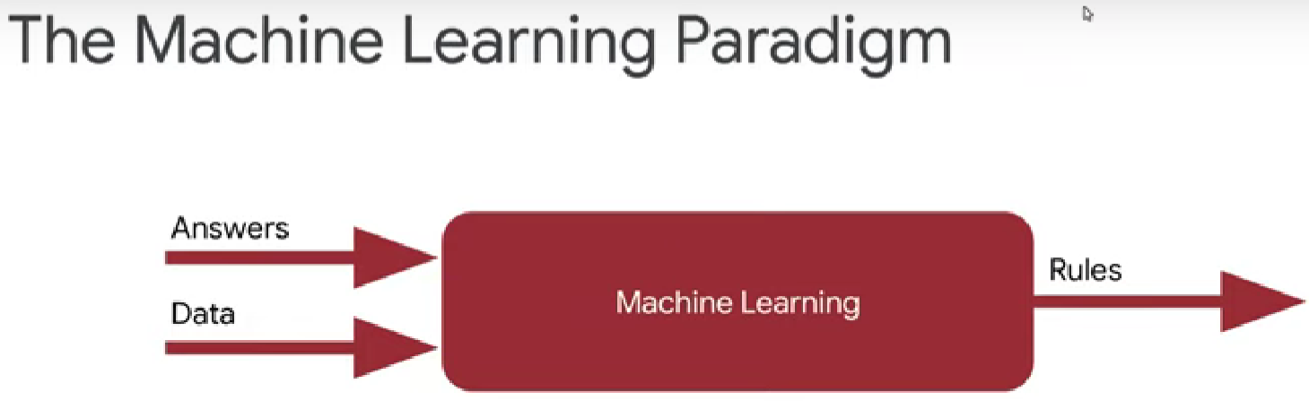

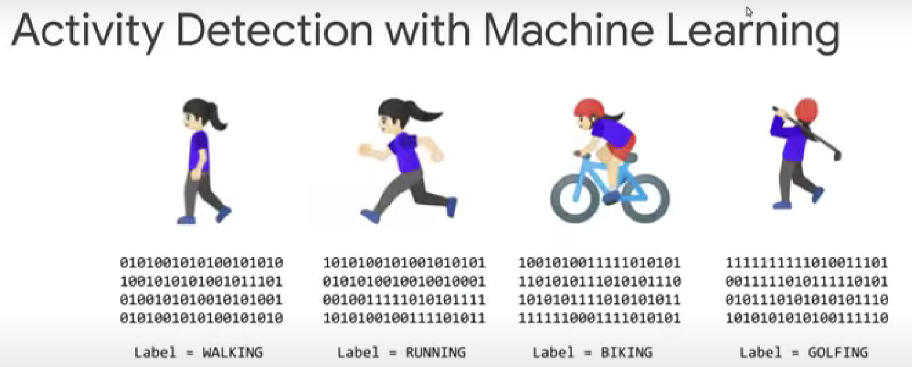



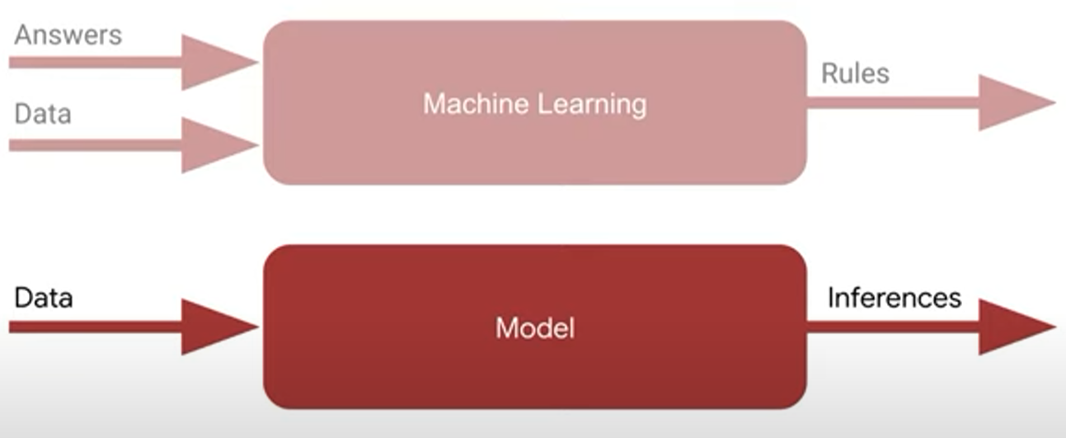

The process to make a guess and measure the guess how good or bad it is and based on that you make another guess and keep improving. Measuring how effective your guess is called as measuring your loss, minimizing your loss means you are increasing your accuracy.